“I’m a flower and like all women am a part of mother nature.We have the power to heal everything in society. We can make the world a better place with our love and care.” -Blond Jenny

Blond Jenny is a painter, photographer, and filmmaker. Her work is a mix of storytelling through her alter ego, cartoon character Blond Jenny, her self-portraits, found objects from nature, 360-degree photos and videos.
Her recent work is focused on nature, women’s rights, and American politics. She uses video and self-photography with mix media to expand the range of expression in her photography. She continues to develop techniques so she can challenge the boundaries of her expression. She likes to explore new media and play with it as part of her overall story. Her intent is to show that with nature or flowers we can be more connected and happy. She has found freedom in nature and continues to explore the path between life, death, and beyond.
Recent exhibits include Pow(h)er, Benjamin J. Dineen III and Dennis C. Hull Gallery, New Jersey; Video Art Department for Splice Film Fest Finalist Award Winner (2nd Place), New York City ; International Fine Arts Film Festival, Santa Barbara, CA ; MiraBan Video Art Showcase, Official Selection, Milan, Italy ;Geumgang Nature Art Biennale, South Korea ; Block 2 Video Exhibition Artist Honorarium Raleigh, NC; Feminism Media Artivist Biennale Short Film Exhibit, South Korea and Photography Department for Kathryn Markel Fine Arts. Her work has also been selected by the following shows Hipster & Otaku Photography Exhibition CICA Museum; Trending: Contemporary Art Now Exhibition Target Gallery for the Women’s Caucus for Art; and Duality of Feminine and Feminist Exhibition Gallery 66.

“Blond Jenny’s relationship to nature is intimate, even erotic, in her self-portrait with purple freesias. Floral images have long been a stand-in for sexuality, but in Blond Jenny’s decoupaged panels are more explicit.” – Marilla Palmer

‘과거와 현재의 꽃, 한글, 여성그리고 자연’의 연결고리를 찾는 과정’
소중히 바라본적없었던 것들에게서의 새로운 발견을 하며, 그 과정을 다양한 매체로 담고 재해석해본다. 관람객의 참여로 이루어질 Nature Bed는 언젠가는 우리가 자연으로 회귀 할 것임을 인식하고 조금더 관심을 갖고 환경을 되돌아 보기를 이야기한다.
- Nature Reimagined
최근, 한편으로는 사회참여적인 작업을 했고 다른한편으로는 자연을 담았다. 이는 발란스를 조절하여 어떤 때는 긴장을 풀고 또 어떤 때는 평화와 평온을 느끼게 해주었다. 자연작업으로 여성성을 표현한다. 이것은 자화상이다. 자연은 나의 감춰진 솔직함과 존재를 찾게해주었다. 꽃과 잎을 말려 그것들을 이용해 이야기를 그린다. 이 과정은자연과 가까와지게 해주었고, 만족감과 기쁨의 원천이다.
- Sign of Woman (Calligraphy)
여성성을 한글서예와 말린 꽃잎들로 표현한다. 동양적인 스타일의 복합재료에 초점을 두는데, 서울에 있는 가족을 향한 그리움이 이 작업을 시작하게 한 원동력이다. 꽃과 모국어가 편안함을 준다. 혀의 모양과 말할때의 입 그리고 자연에 기본을 둔 상형문자인 한국어가 얼마나 아름다운지를 인식하지 못했다. 조선시대 세종대왕의 훈민정음에서 기본모음 ‘ㆍ’ 은 하늘 ‘ㅡ’ 은 땅 그리고 ‘ㅣ’ 은 사람이 그들사이에 서있는 것이라고 했다. 이 형상들의 의미는 사람이 얼마나 자연과 함께함을 행복해 했는지 보여주는 전형적인 동양적관점이다. 자연에게 겸손했던 사람이 만든 과학이 있기전의 과거로 간다. 환경에 경의를 표하고 있고, 다른 사람들도 그렇게되기를 바란다. 한국어 단어와 소리들을 이용해 여성성을 묘사한다.
이 프로젝트 초기에는 한글서예를 중심으로 시작되어 그것은 과거를 여행하는 것과 같았다. 점차 나를 참여시켜 좀더 모던화된 서예스타일을만드는 것을 발견했다. 칼리그래피 작업은 인공적인것과 자연이 음악과 같이 하나되는 것을 보여준다. 검은색과 빨간색 점, 그리고 꽃잎을 이용하는데 마치 노래가 적힌 음악악보같다. 그것들은 한글, 색, 그리고 공간을 통해 음악을 만든다. 한글의 의미는 공기와 대자연이 우리를 둘러싸고 있는데 얼마나 중요한가는 인식하지 못하는 것과 같다.
I set out to find the connection between flowers, Korean language, women, and nature from the past and present. This is my reinterpretation of many media used to capture the process and discover a new view from the unseen and underappreciated. The Nature Bed will be interactive for visitors like taking part in my funeral. We will go back to nature someday so this is an opportunity to show our gratitude while we can.
- Nature Reimagined
Lately, I’ve rotated my work between social activism on one side and capturing my feelings in nature on the other. This provides a balance for me that sometimes releases tension and other times brings me peace and tranquility. In this nature work, I want to express my womanhood. This is my self-portrait. Nature unreleased my honesty and through it I found my existence. I collected these flowers and leaves, dried them, then used them to illustrate my story. This process brings me closer to nature which is a source of joy and satisfaction for me.
- Sign of Woman (Calligraphy)
I express my womanhood through Korean calligraphy and dried flower petals. I am focused on oriental style mixed media inspired by the nostalgia of missing my family back home in Seoul. My comfort with flowers and my mother tongue made me the woman I am. I didn’t realize the beauty of the Korean alphabet which is based on hieroglyphs, the shape of the tongue and mouth while speaking, and nature. The Joesun dynasty King Sejong describes in his book Hunminjeongeum (The Proper Sounds for the Instruction of the People) the basic vowel ‘ㆍ’ as meaning sky, ‘ㅡ’ is the shape of land, and ‘ㅣ’ is a human standing between them. The meaning of these shapes shows how humans are happy to live with nature, a common Oriental view. I go back to the time before man-made technology when we were humble to nature. I am paying homage to our environment in hopes that others will too. My work is a compilation of self-identified Korean words and sounds used to describe my femininity.
These include:
- 그녀 / Geu Nyeo / Her
- 녀성 / Yeo Sung / Female
- 대자연 / Dae Ja Yeon / Mother Nature
- 꽃 / Kkot / Flower
- 산 / San / Mountain
- 녀 / Yeo / Female
- 아내 / Ah nae / Wife
- 꽃잠 / Kkot Jam / Sleeping with flowers
- 녀자 / Yeo Ja / Woman
- 딸 / Ddal / Daughter
- 며느리 / Myeo Neu Ri / Daughter In-law
- 녀인 / Yeo In / Lady
In the beginning of this project I started with only Korean calligraphy which was like traveling back in time. I slowly found myself evolving the pieces to a more modern style of calligraphy. My calligraphy work shows harmony between things both manmade and nature like music. I use black and red dots and flower petals as if they are the musical notes of a song. They are making music through the alphabet, color and space. I share what Korean words mean to me because like both air and mother nature we are surrounded without always realizing how important they are to us.
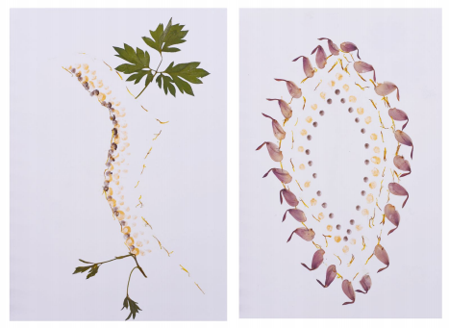
Title: Tree (Left)
Year: 2020
Medium: Dried flower petals with gouache on paper
Size: 7 x 10 inches
Title: Woman Drawing(Right )
Year: 2020
Medium: Dried flower petals with gouache on paper
Size: 7 x 10 inches
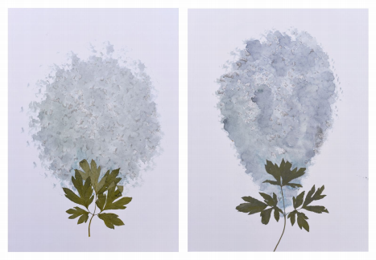
Title: Flower #1, #2
Year: 2020
Medium: Dried leaf, pencil with gouache on paper
Size: 7 x 10 inches each
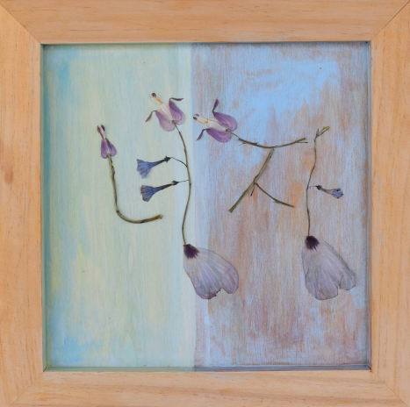Title: 녀자 / Yeo Ja / WOMAN
Year: 2020
Medium: Dried flower petals with gouache on wood panel
Size: 12 x 12 inches

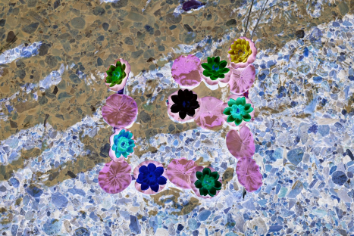Title: Negative 녀자 / Yeo Ja / WOMAN
Year: 2020
Medium: Archival pigment printing
Size: 30 X 40 inches
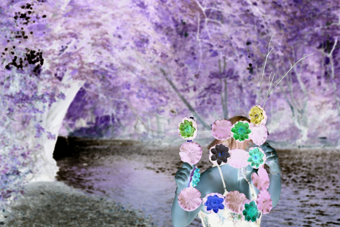
Title: Negative 녀자 / Yeo Ja / WOMAN #2
Year: 2020
Medium: Archival pigment printing
Size: 30 X 40 inches
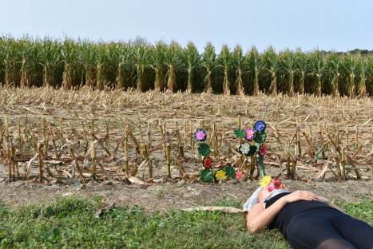Title: 녀자 / Yeo Ja / WOMAN
Year: 2020
Medium: Archival pigment printing
Size: 30 X 40 inches
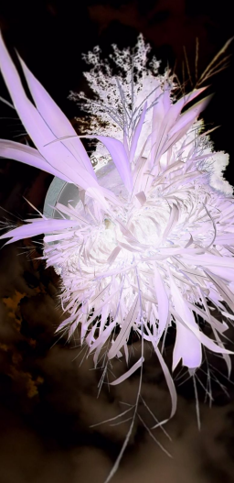
Title: Negative Pink Flower
Year: 2020
Medium: Archival pigment printing
Size: 40x30 inches
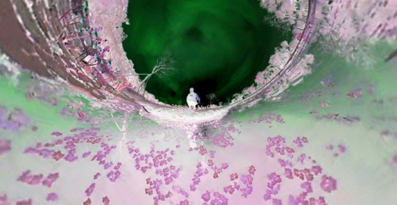Title: Unseen Passage
Year: 2020
Medium: Archival pigment printing
Size: 20 X 30 inches
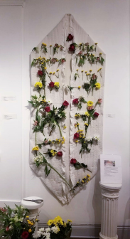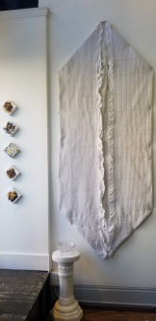
Title: Nature Bed Interactive
Year: 2019
Medium: Flowers on fabric
Size: 5x7 feet
Nature bed is a celebration of life and the afterlife. It is my exploration of a funeral. I made my first nature bed in Pennsylvania in the Summer when there were lots of flowers I could collect. I recreated the bed at Bushwick Open Studio this past year. It started as an empty bed and I asked my visitors to add flowers to the bed however they liked. I took photos of the bed after each visitor’s contribution. The last visitor was able to lay down and could enjoy the bed. This project was displayed during the International Women’s Show to celebrate unity so the visitors can participate in my project. We are always surrounded by nature and will go back to nature. I show that life is short and nature has the answer for many of my questions.
자연침대는 삶과 사후세계를 축복한다. 나의 장례식을 상상하며 이작업을 진행했다. 첫 자연침대는 2년전 여름, 펜실베니아에서 많은 꽃들을 수집해서 제작되었다. 부쉬위크 브룩클린 오픈스튜디오때 두번째 자연침대를 제작했는데, 나의 스튜디오에 방문한 관람객들이 빈 침대를 그들의 취향에 맞게 준비된 꽃들로 채워 주었다. 마지막 방문자는 누워서 침대를 즐길 수 있었다. 이 작업은 2019년 방문자들이 참여로 하나가 되고 축하하는 의미로 여성전시회동안 2019년 갤러리 107Bowers gallery에서 전시되었다. 우리는 자연에 둘러싸여있고 자연으로 돌아갈 것이다. 나는 삶은 짧고 자연이 많은 내질문에 답을 가지고 있다는것을 보여준다.
아래는위의 자연침대의 브룩클린과 팬실베니아에서의 설치이미지와 과정설명입니다.
The collaboration started during Bushwick Open Studio 2018
My Nature Bed Installation (2018) work was a spiritual experience for me.
I collected flowers at my father in law's farmhouse in Pennsylvania where I created my first Nature Bed. After that, I wanted to share the process with artists and art lovers who came to my open studio in Bushwick.
As a woman artist, I try to heal myself and society through nature because people have lost their ability to connect. Nature Bed is the experience of my funeral that I am sharing with the world. I came from Mother Nature and will go back to nature. This is the celebration of life and death. For me, it is peaceful and free from interruption.
My second Nature Bed was a collaboration with amazing artists including Marilla Palmer, Zee Bdr, Eva FC Muller, Nina Kuriloff, Marne, Kenneth, Nicole, Eleanor and Taline.

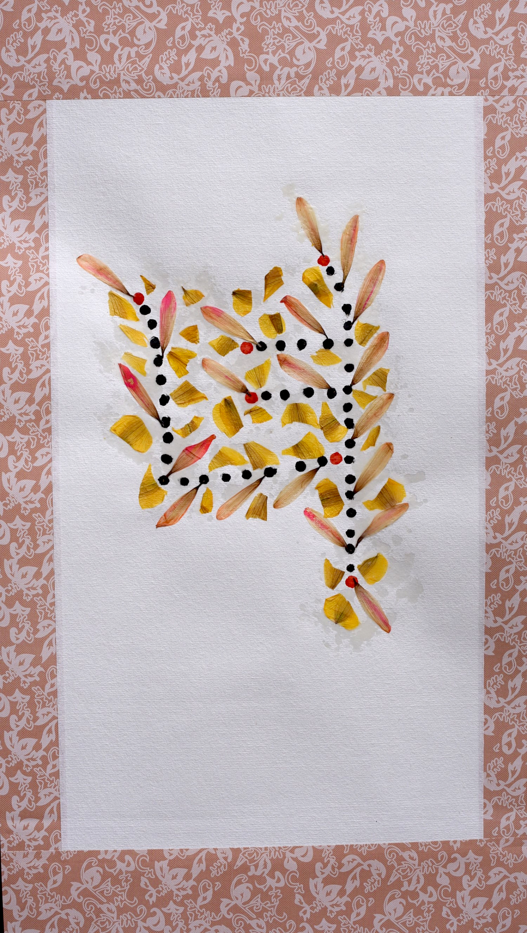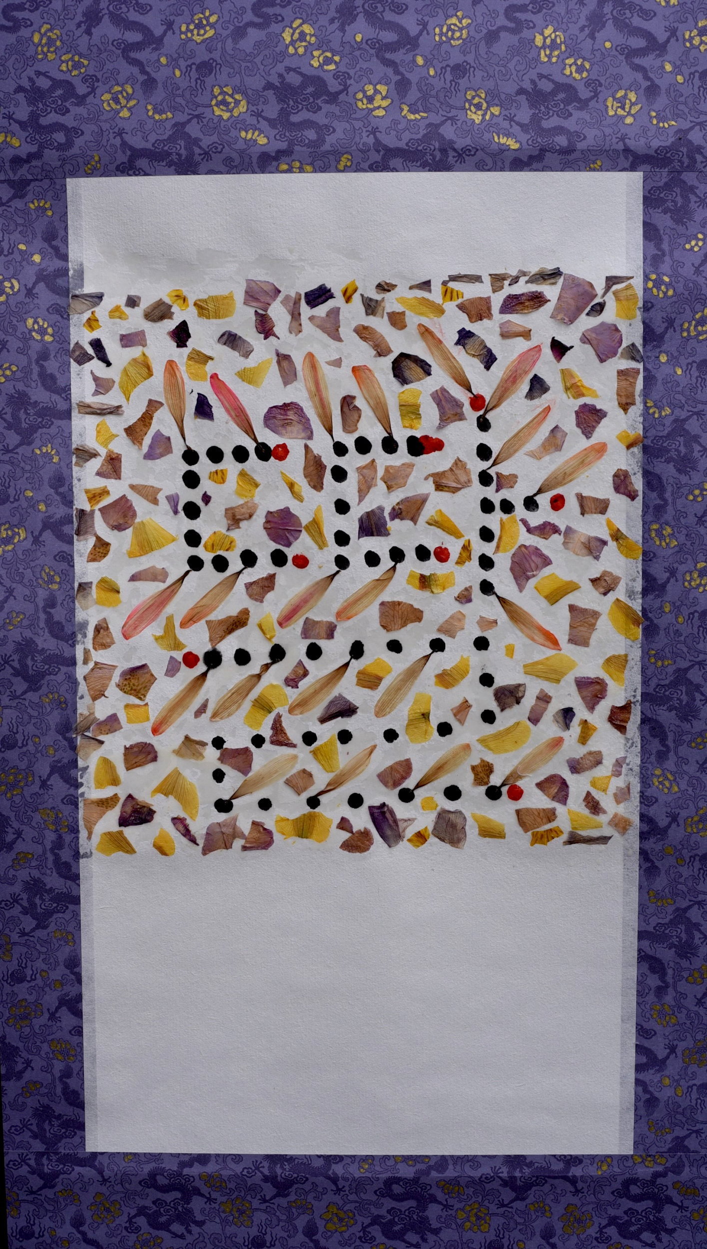

녀 & 딸 (타이포그라피 인스탈레이션) Yeo/Yeo Ja/Woman & Ddal/ Daughter Typography

이 작업은 예를 위해 첨부한 이미지입니다. (미술관사정에 협의후 진행) 벽면에 꽃잎과 스티커, 혹은 테이프를 이용해 글자를 흰벽에 만듭니다.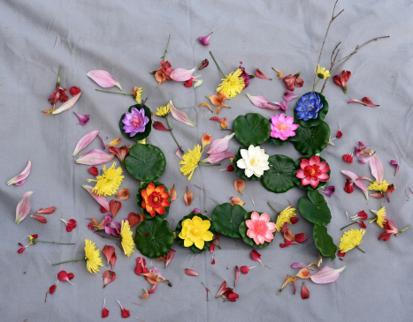
Title: Yeo Installation
Year: 2020
Size: 40 X 40 inches
Medium: Artificial flowers, real flower petals and twigs
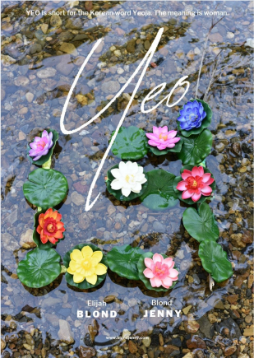
Title: YEO
Year: 2020
Medium: Video
Running Time: 1min 46sec
YEO is short for the Korean word Yeoja. The meaning is the woman.
In nature women are free and there are no interruptions. Women absorb nature’s energy and become one with it. I’ve obscured the word in the beginning and end of the video to show how the water cleanses us between when we enter and leave this world. The label YEO is given to us while we are alive but is released after we surrender ourselves back to nature.
녀는 한국어 여자의 줄임말이다. 의미는 여자이다. 자연에서의 여성은 자유로우며 방해를 받지 않는다. 여성은 자연의 에너지를 흡수하고 점차 그것과 하나가 된다.
나는 이 단어를 초반과 결말의 비디오를 가려서 우리가 태어나고 떠나는 이 세상을 어떻게 물이 우리를 정화켜 주는지 보여준다.
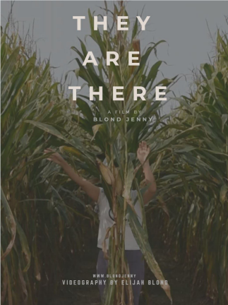
Title: They are there
Year: 2020
Medium: Video
Running Time: 2min 54
If you don't notice, you can’t see them. They exist and are there for us. They are dancing with the wind and telling us their story. Whenever you look back, they will be there.
주의깊게 보지않으면 그들을 볼수없다. 그들은 존재하고 우리를 위해 거기에 있다. 그들은 바람과 우리에게 그들의 이야기를 하며 춤을춘다. 그들은 당신의 뒤에 있을것이다.
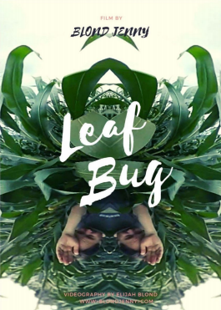
Title: Leaf Bug
Year: 2020
Medium: Video
Running Time: 2min 54
A man walks through a field and becomes a huge leaf bug. He sees through bug eyes and is free to fly in the sky with his wings. We came from nature and will go back to nature. We might become flowers, animals, butterflies, or even a bug.
한남자가 들판을 향해 걸어가다 점점 거대한 잎벌레가 된다. 그는 벌레의 눈을 통해보고 자유롭게 날개짓을 하며 하늘을 난다. 우리는 자연에서 와서 자연으로 돌아갈것이다. 우리는 아마도 꽃,동물, 나비들 또는 벌레조차 될지도 모른다.

